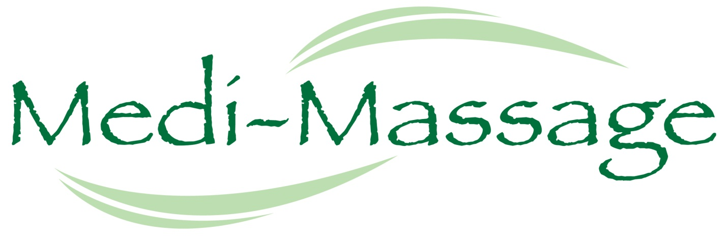
Pain and Stress Focused Medical Massage…
The Way You Want It
Gone are the days of the cookie-cutter massage. At Medi-Massage, we cater to our client’s specific needs. Our therapists are trained in many different styles of massage from relaxation to therapeutic pain relieving medical and sports massages. We have mastered the art of the completely personalized massage. Please fill out the following 7 questions so that your therapist can provide the perfect individualized massage for you. We will stop at nothing to make sure we provide you with the “Ahhh” moment.
- Where would you like the therapist to focus:
__ Full body __ Neck & Shoulders only
__ Full Back & Neck __ Feet (see below #9)
__ Low Back only __ Other
Please indicate where your pain or discomfort is on the chart below:
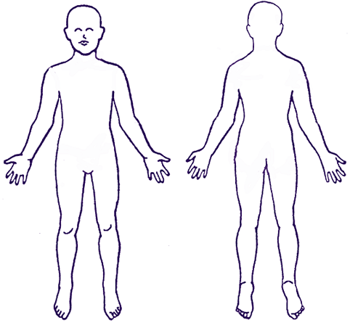
- What amount of pressure do you like:
__ I’m not sure __ Hard (Deep)
__ Very Light __ Other__________________
__ Medium
- Are there any areas you would like the therapist to avoid: __ No
__ Yes: _________________________________________________
- Do you prefer:
__ Silence __ Small talk __ A mix of silence & small talk
- What aromatherapy would you like to add: (+$10 add on)
__ Lavender – Calming/reduce stress & anxiety/promotes good sleep
__ Lemongrass – Soothes muscles and nerve pain
__ Sweet Orange – Increase happiness/health benefits
__ Eucalyptus – Remove negative energy
__ Peppermint – Cooling/refreshing
__ Tea Tree – Fights bacteria, fungi, and viruses
__ None
- What would you like to listen to:
Relaxation music: Sounds of:
__ Classical __ Seashore
__ Jazz __ Rain
__ New age __ Rainforest
__ Piano __ Stream
OR __ Therapist’s Choice
*You may change your mind at any time.

Enjoy your massage!

Massage Client Waiver Form

Please take a moment to read the following information:

I understand that massage therapy is provided for stress reduction, relaxation, relief from muscular tension, and improvement of circulation and energy flow.

If I experience pain or discomfort during the session, I will immediately inform my therapist so that
pressure/strokes can be adjusted to my level of comfort. I will not hold my therapist responsible for any pain or discomfort I experience during or after the session.

I understand that the services offered today are not a substitute for medical care.

I understand that my therapist is not qualified to perform spinal or skeletal adjustments, diagnose, prescribe, or treat physical or mental illness.

I affirm that I have notified my therapist of all known medical conditions and injuries.

I agree to inform the therapist of any changes in my health and medical condition. I understand that there shall be no liability on the therapist’s part should I forget to do so.

I understand that massage is entirely therapeutic and non-sexual in nature.

By signing this release, I hereby waive and release my therapist, Medi-Massage LLC, Grano Pain Relief and Wellness Center, and all staff, affiliates, contractors from any and all liability, past, present, and future relating to massage therapy and bodywork. I have received the policy statement, and have read and agree to the policies therein.

Client Name:_________________________________________Date: _____________

Client signature:______________________________________________________

Therapist signature:___________________________________________________

Information and Suggestions

Prior to your massage, please remove all jewelry and contact lenses.
Pull long hair back with a clip or band. Please only undress as much
as you are comfortable.

Everyone enjoys massage differently, YOU MUST LET THE THERAPIST
KNOW IF YOU WANT MORE OR LESS PRESSURE. Feel free to ask your
therapist any questions before, during, or after the session. Your therapist
is a highly trained professional and will be happy to make you feel informed
and comfortable.

