GRANO PAIN RELIEF & WELLNESS CENTER PATIENT CASE HISTORY

Name: Date: Street Address: _ City: State: Zip: _

Home Phone: ---------
Work Phone: --- --- ---
Cell Phone: --- --- -----

Best way to get a hold of you: Home - Work - Cell May we leave a message for you at these locations? Yes - No Email Address: Occupation: _
Date of Birth: Age: Social Security#: _
Height: _ Weight: lbs. Gender: M F Race: Caucasian Asian African American Hispanic Other: _
Marital Status: M D S W Spouse Name: Spouse Date of Birth: _ Emergency Contact Phone: WHOM MAY WE THANK FOR REFERRING YOU?

PLEASE MARK YOUR AREAS OF PAIN ON THE DIAGRAM
FOR OFFICE USE ONLY

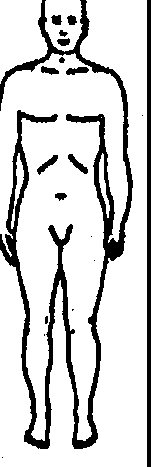
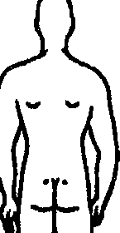

,, .

What is your major complaint? Date problem began? _ How did this problem begin (falling, lifting, car accident, etc.)? _ How is your condition changing? D GETTING BETTER CJ GETTING WORSE D NOT CHANGING
Have you had this condition in the past? YES - NO
How often do you experience your symptoms?
- Constantly (76-100% of the day) □ Frequently (51-75% of the day)
- Occasionally (26-50% of the day) □ Intermittently (0-25% of the day)
Describe the nature of your symptoms: □ Sharp [J Dull □ Numb □ Burning □ S hooting □ Ti ngling □ Radiating Pain
□ Achy □ Tightness □ Stiffuess □ Swelling □ Stabbing □ Throbbing □ Other: _
Please rate pain on a scale of 1 to 10 (0= no pain and 10= excruciating pain) □ l □ 2 □ 3 IJ 4 □ 5 □ 6 □ 7 □ 8 □ 9 □ 10 How do your symptoms affect your ability to perform daily activities such as working or driving?
(0= no effect and 10= no possible activities) □ 1 □ 2 [J 3 □ 4 lJ 5 D 6 [l 7 □ 8 D 9 □ 10
What activities aggravate your condition (working, exercise, etc)? What makes your pain better (ice, heat, massage, etc)? _

PATIENT CASE HISTORY- Page 2

List any Allergies:
- Animals □ Aspirin □ Bees □Chocolate □ Dairy [I Dust [I Eggs □ Latex D Molds □ Penicillin D Ragweed/Pollen
- Rubber □ Seasonal Allergies □ Shellfish D Soaps [l Wheat □ X-Ray Dye D Other _

List any Surgeries including dates:

- Back _
- Foot _
- Wrist _
Other: _

- Neck ----
- Hip _
rJ Neurological

- Elbow ----
[I Knee----
[I Shoulder ----

List ALL Past Medical History conditions:
- Ankle Pain □ Arm Pain [I Arthritis □ Asthma D Back Pain [J Broken Bones □ Cancer D Chest Pain □ Depression
D Diabetes D Dizziness D Elbow Pain D Epilepsy D Eye/Vision Problems □ Fainting □ Fatigue □ Foot Pain
D Genetic Spinal Condition D Hand Pain [I Headaches □ Hearing Problems □ Hepatitis □ High Blood Pressure
- Hip Pain D HIV □ Jaw Pain D Joint Stiffness □ Knee Pain □ Leg Pain [J Menstrual Problems [l Mid-Back Pain
- Minor Heart Problem □ Multiple Sclerosis □ Neck Pain □ Neurological Problems [I Pacemaker [l Parkinson's
D Polio D Prostate Problems D Shoulder Pain D Significant Weight Change [J Spinal Cord Injury D Sprain/Strain
- Stroke/Heart Attack □ Other: _

Who is your: Primary Care? Orthopedic doctor? _ Rheumatologist? Other doctors?

List of Medications you are taking:
- Pain Killers □ Muscle Relaxers [J Anti-inflammatory _
DCardiovascular (Blood Pressure) IJ Insulin □ Birth Control _
- Allergy □ Anxiety [JOther: List Vitamins and Supplements: Are you pregnant? □ No [J Yes (X-rays are harmful for a developing baby)

List your Family History:
Please indicate which family member has/had the following: Mother, father, on, !;!aughter, ibling
_ Arthritis _ Asthma_ Back Pain _ Cancer _ Depression _ Diabetes _ Epilepsy _ Genetic Spinal Condition
_ High Blood Pressure_ Heart Problems_ Multiple Sclerosis_ Neurological Problems_ Parkinson's_ Polio Prostate Problems Stroke Heart Attack Other:

Have you had any auto or other accidents? D No □*Yes when?-------------------
Describe: ---------------------'--------------------

*If injuries are due to an auto accident, please ask at the front desk for a Motor Vehicle Questionnaire.

Injuries you have had: Description(s) Date(s)

Falls Head Injuries Broken Bones Dislocations
Date of last physical examination:
Do you smoke? □ No □ Yes - How many per day? _ Have you smoked in the past? □ No □ Yes
Do you drink alcohol? □ No □ Yes - How much per day? _ Do you drink caffeine? □ No □ Yes - How much per day? _
Do you exercise? □ No [J Yes - (what forms and how often): _ Have you ever had chiropractic care? □ No [I Yes
If yes, Where?

When? Why? _ Were X-rays taken? □ No [I Yes Do you have MRis of your spine? □ No □ Yes
When was your last adjustment? _
Please list specific things you liked or disliked about your past chiropractic experiences?

We are a total wellness center, are you interested in more information on any of the following?:

- Weight Loss Program
-Reduce weight on joints
□ Private Massage (25 min I 50 min)
-Loosen tight painful muscles
□ Spinal Pelvic Stabilizing Orthotics
-Support your posture from the foundation

X
PRINTNAME SIGNATURE DATE

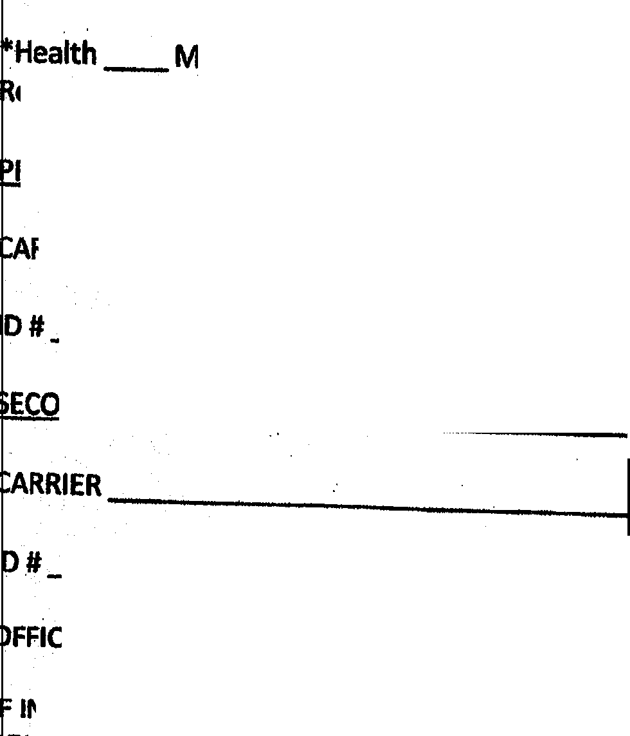PATIENT INSURANCE INFORMATION
Date of Bir) th

Health_ Medicare_ Auto/PIP_ Workers Comp_ elationship to Insured: Self_:_ Spouse_ Child._

IMARY INSURANCE. INFORM TION:

Group#

MATION:.

Group#

FFICE POl,.ICY REQUIRES PAYMENT FOR OFFICE VISITS BE MADE AT THE TIME OF SERVICE.

I INSURANCE COMPANY REQUIR S A REFERRAL FROM YOUR PCP (PRIMARY CARE PHYSICIAN), IT IS PATIENT'S
ESPONSIBILITY TO OBTAIN THE REFERRAL. '

NOTE: Your treatment received in this office may not be covered by your insurance company if received in
y other specialist office. (I.e. physical t he rapy1 acupuncture) on the same day. This will result in an additional ·
c arge to your account.
SSIGNMENTS OF BE.NHlT$. ANO AUTPflfdTV !1 .RFl r.11.c;,r !Nf.'n r,fl..t.TU"IM•
I ereby authorize the above named insurance comoanv to oav directlv to.C-.r;1nn r:hirnnrm-Hr n,:.ntPr ::ill·
I . , .
b nefits due to. me'for :::.crvices rendP:rPrl .::, rJf"O\iirl,,,.,l fnr iri l"fl\/il'", HT I',"'."' "'"'liru , .. ,m "''"'" ""'·-..II· ......-... ......
I curred or for all harges in exr..e$S of whatever sl!.ms !'!ot paid 1,y the iP-surance company.
F rther, I authorize release of information deemed appropriate concerning my physical condition to any
I surance. company, attorney, adjuster and/or other physician that is acquired during my treatment with this
e recognize hat there a e sometimes valid reasons for no shows and late.cancellations, that place a
s· eciuUng, starfing, and financial burden on the office.and prevent other patients from obtaining
c1 pointments in a timely manner.

e reserve the right to charge a $45.00 fee to your account for no shows and late cancellations. This fee is
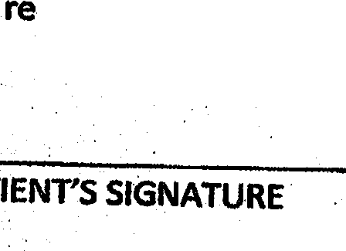n t billable to your insurance con-1pany.

e require all cancellations within three hours prior to your appointment time.

TODAY'S DATE

Informed. Consent to Care
You are the decision maker for your health care. Part of our role Is to provide you with information to assist you in making informed choices. This process is often referred to as "informed consenr and involves your understanding and agreement regarding the care we recommend. the benefits and risks associated with the care, alternatives, and the potential effect on your health if you <:hoose not to receive the care.
We may conduct som · diagnostic or examination procedures if indicated. Any examinations or tests conducted will be carefully per.formed but may be uncomfortable. · ·
Chiropractic care centrally·involves what is known as a chiropractic adjustment. There may be additional supportive procedures or recommendations as well. When providing an adjustment, we use our hands or an in trument to reposition anatomical structures, such as vertebrae. Potential·benefits of an adjuJtment include restoring normal joint motion, reducing swelling and inflammation in a joint, reducing pain in the joint, and Improving neurological functioning and overall well-being..
It is important that you understand, as with all health care approaches, results are not guaranteed, ancUhere Is no.Promise to cure. As with alltypes of health.care interventions, there are some risks to including, but not limited to: muscle spasms, aggravating and/or temporary increase in symptoms,· lack of improvement of symptoms, bums an /or scarring from electrical stimulation and from hot or cold therapies. including but not limited to not packs and Ice, fractures (broken bones}, disc injuries, strokes, dlsloaaticms, strains, and sprains.
care,
. Wrth respect to.strokes, there .is a rare.but serious condition known as an "arterial dissection• that typlcally Is caused by a tear in the inner layer of the artery that may cause the development of a thrombus (Qot) With the potential to l d to a stroke. The bestavailable scientific.evidence supports the understanding that c adjustment does not cause a dissection in a normal, healthy artery. Disease procenes. genetic disorders,
· medications, and vessel abnormalities may cause an artery to be mote susceptible to dissection. Strokes . caused by arterial dissections have been associated with·over 72 everyday activities such as sneezing, driving, and playing tennis.
Arterial dissection• occur in 3-4 of every 100,000 people whether they are receiving health care or not Patients who experience this condition.often, but not always, present to their medical doctor or chiropractor with neck pain and headache. Unfortunately a percentage of these patients will experience a stroke.
The reported association between chiropraotlc visits and stroke is exceedingly rare and is estimated to be related in one 1n one million to one in two million cervical adjustments. For comparison, the incidence of hospital admission attributed to aspirin use from major GI events of the entire (upper and lower) GI1ract was 1219 events/ per one mlHion pe®ns/year arid risk'of death has been estimated as·104 per one million users.
It is also il1'lportant that you understand there are tre;atment options available for your condition other than chiropractic prQcedures•.Likely; you have tried many of these approaches already. These options may include. but are not limited to: self-administered care; over-the--counter pain relievers, physical measures and rest. medical care with prescription drugs, physical therapy, bracing, injections, and surgery. Lastly, you have the right to a second opinion and to secure other opinions about your circumstances and health care asyou·see flt..
I have read, or have had read to me, the above consent. I appreciate that It Is not possible to consider eve'(IJ possible.complication to care. I have also had an opportunity to ask questions about its content, and by signing below, I agree with the current or future recommendation to receive chiropractic care as is deemed appropriate for my circumstance. I intend this consent to cover the entire course of care -from all providers in this office for my present condJtlon and for any future condltion(s) for which I seek chiropractic care from this office.·

Patient Name: |  | . Signature: | Date:
Parent or Guardian: |  | Signature: | Date:
Wltn&ss Name: | _ | Signature: | Date:

. Grano Pain Relief & Wellness Center

Patient Acknowledgement for Use and Disclosure of Protected Health Information
I hereby give my consent for Dr. Grano.and staff; (Grano Pain Relief & Wellness Center) to use and di&Glose
Protected Health Information (PHI) about me to carry out Trea1ment, Payment and healthcare Operations (TPO).

Ihave 'the right to review the Notice of Privacy Practices before signing this consent The office reserves the right to revise its Notice of Privacy Practices at any time. A revised Notice of Privacy Practices may be obtained by forwarding a written request to the Privacy Officer: Dr. Andrew Grano, 31 State Route 23 N, Hambur& NJ 07419. .

With this•consent, the office may call my house or other alternative location (including cell phone if giv n) and leave a message on voice mail or in person in reference to any items that assist the practice in catrying out TPO, such as appointmep.t remit1ders, insurance items and any calls pertaining to my clinical care, including laboratory results among others.

With this consent. the office may mail to my home or other alternative location or e-mail (if patiel)t wishes to provide e-maU) any itelllS that assist the practice in carrying out TPO, such as appointment reminder cards and patient statements as long as they are marked Personal and/or Confidential. ·

By signing this form, I am Consenting to the office's use and disclosure of my Protected Health Information
(PHI} to carry out Treatment, Payment and healthcare Operations (TPO).

I may revoke my consent in writing except tot he extent that the practice has already made disclosures in reliance upon my prior consent. If I do not sign this consent, or later revoke it, the office may decline to provide treatment to me.
Financial Responsibility
Payments for services are due at the time services are rendered!
If you have a co-pay or deductible, we will accept that until we have reached notice or payment from your insurance company. We will file your claims as a courtesy to you. It is always the patient's resPQllSIOilityto know his or her own benefits. Any nonpayment from an insurance company due to this negligence becomes the patient's fmancial responsibility. You must realize that insurance coverage is an agreement between you and your insurance company. We are not part of that contract. ·.

Our fees normally fall within the UCR, which is defined as the Usual, Customary. and Reasonable charges for this region.· Not all insurances will pay for all services performed at this office. Any unpaid balances not paid by insurance are the patient's .responsibility. I agree that if my account balance with Grano Chiropractic is outstanding for more than 60 days it will be submitted for collection. In addition to interest charged, I agree to pay all collection costs, including, but not limited to, attorney•s fees and court costs.
I fully understand this agreement between this office and myself. I am ultimately responsible for the balance of
my account for any professional services rendere:d.

Signature of Patient 'Date

Patient Name (Print)

